Team Number: 1
Team Members: Drew Medlock, Blake Pennel, Kyler Russell, Luke Reicherter, Alex Rawson, Carter Steenhard, Kyle Fleming
Project Name: Waze’o’matic
Project Synopsis: Using an ONNX runtime camera data is ingested to classify any hazards that are autonomously reported on the user’s Waze app.
Link to Requirements Spreadsheet: Link

Architecture Description:

The pipeline overview starts with intake at a continuous camera feed. We are designing to have 2 possible modes: on-device camera, and external camera. The data from this camera is then fed into preprocessing for inference. With the on-device camera setup the inference is performed within the same device using the ONNX runtime. With an external camera the data is transferred to a RPI for pre-processing and inference using the ONNX runtime as well. After inference processes the camera feed if any hazards were detected the data is then passed to the phone through an app that uses the accessibility features of the phone to automatically make a report in the Waze app with access to the static members of the UI. Each part of this pipeline is detailed in further detail below, with appropriate UML diagrams.
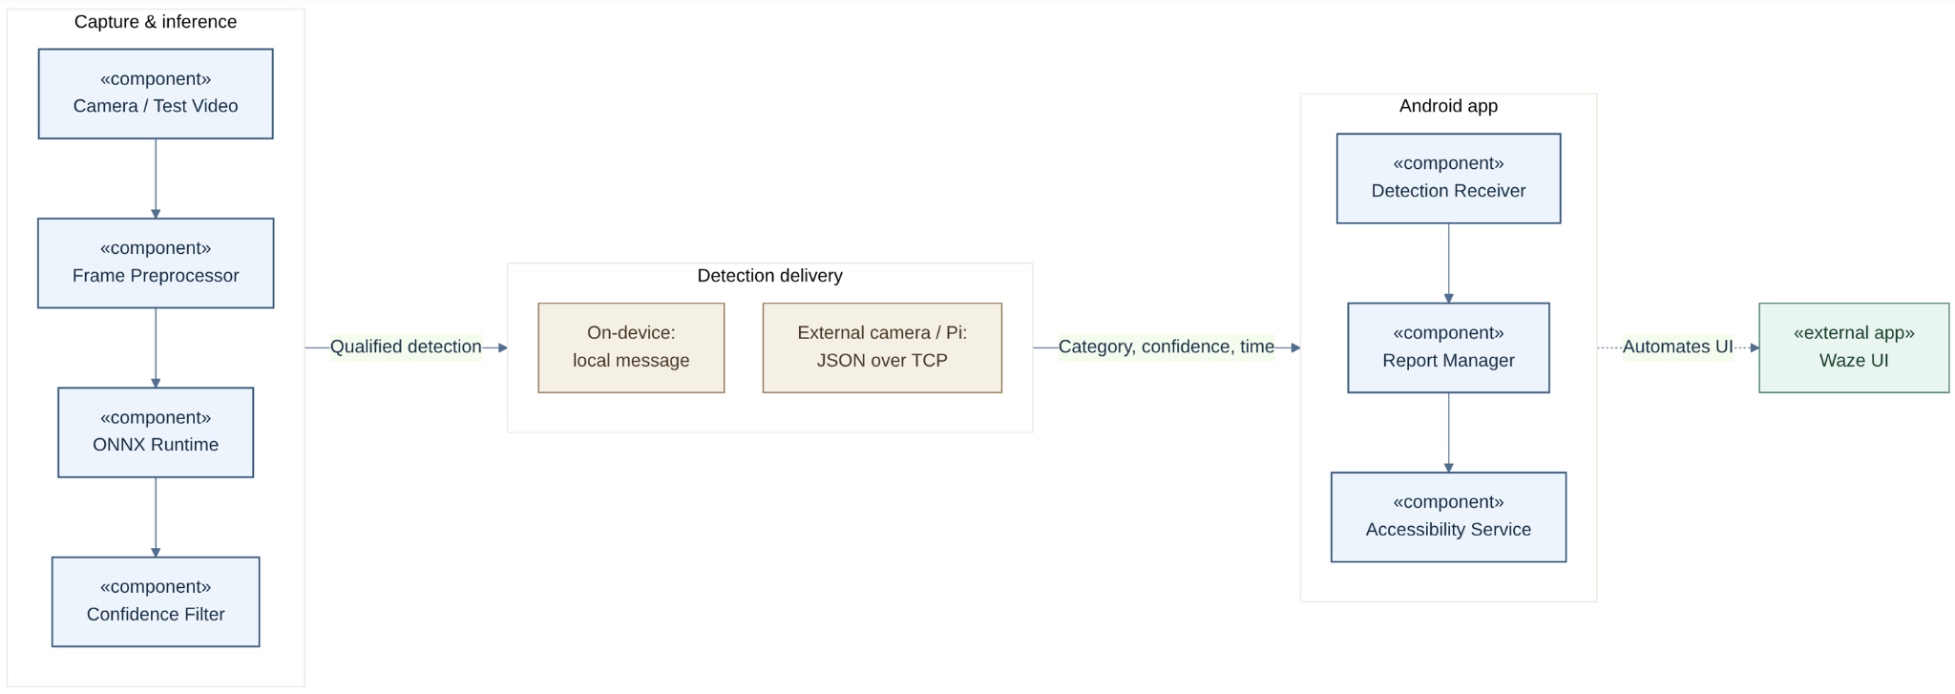
Waze’o’matic: Component Diagram
The data pre-processing step starts with the simplest part of data capturing using the camera. The camera is simply based on the hardware, and because of the inclusion of multiple camera sources, when the data is moved to pre-processing it is turned into a set size before being passed to inference. Along with resizing, each frame is normalized so that it matches the format the model was trained on. Since the phone and the RPi can’t run inference on every frame a camera produces, we only take frames at a set rate and any that are left over are dropped instead of queueing them. This keeps detections focused on what is currently in front of the car. For testing, a pre-recorded video can be used in place of the camera, and its frames go through the exact same preprocessing.
Inference is handled by the ONNX runtime on both the phone and the RPi, so a model only needs to be exported once and can run on either device without being converted again. For Sprint 1, we will be using a general pre-trained model to get the pipeline working end to end, and the dedicated models will be added in later sprints. After the model runs, any detection under a set confidence score (ex: 0.7) is logged but not acted on. Detections at or above that threshold are packaged into a message with the hazard category, the confidence score, and the timestamp.

How this message gets to the reporting app depends on what mode is being used. In the on device mode, inference and the reporting app are on the same phone, so the message is passed along directly. In the external mode, the RPi sends the message to the phone (over USB via ADB). The RPi also lets the phone know if the camera goes offline, and if the connection to the phone is lost it keeps running and attempts to reconnect.
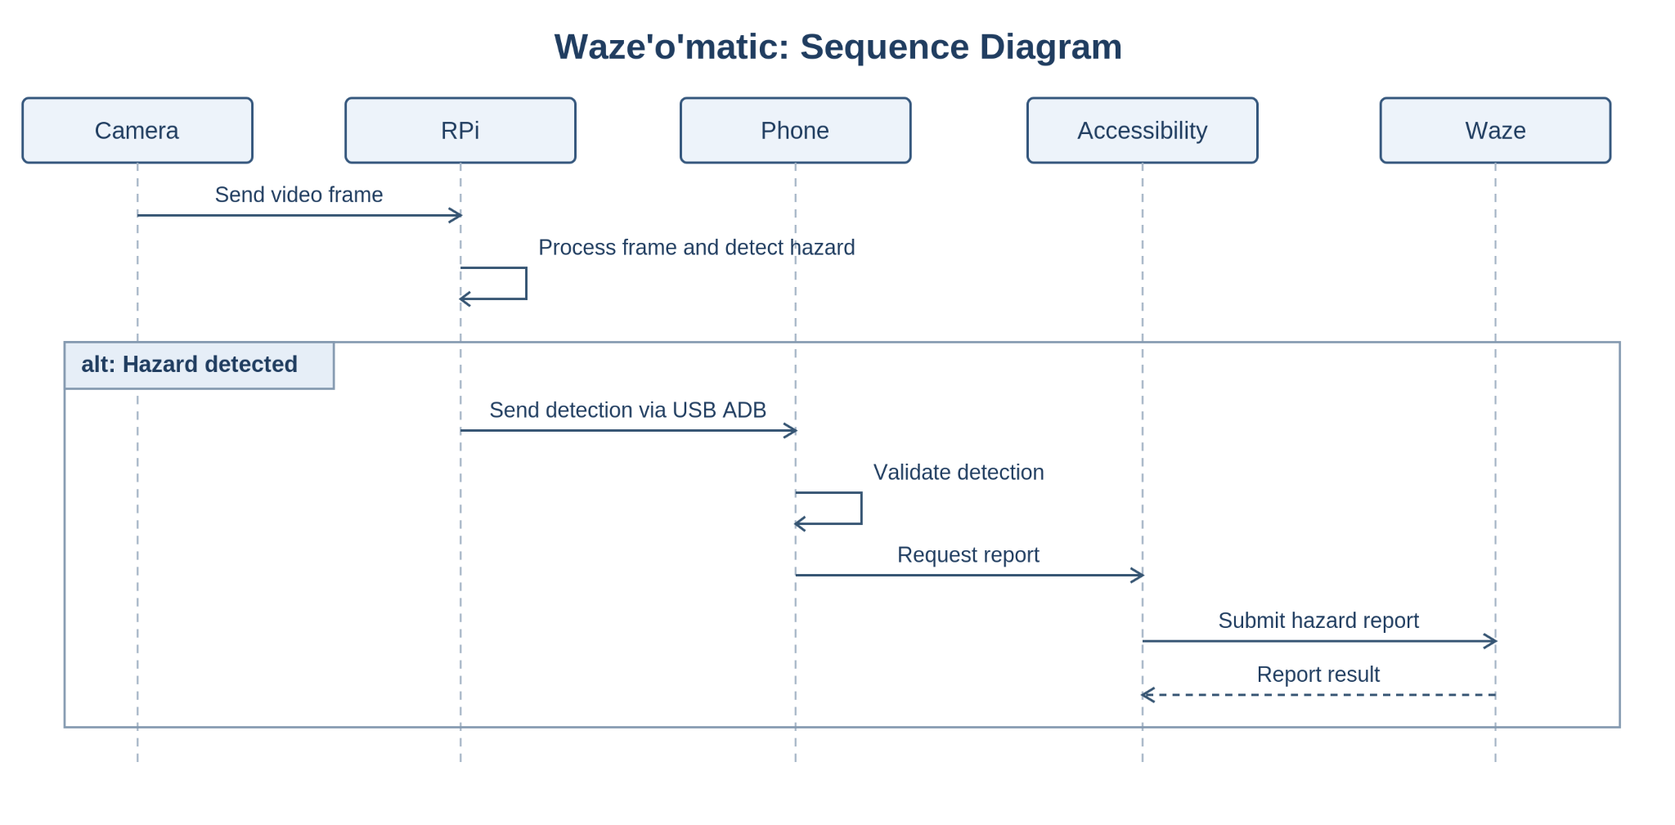
Waze’o’matic: Sequence Diagram
When the phone receives the detection, the reporting app takes over. The app is built on Android's accessibility service, which lets it read and interact with the Waze UI once the user gives it permission. Before doing anything, the app checks that this permission is still enabled, and if it isn’t, asks the user to turn the permissions back on. The detection category is then matched to the corresponding Waze report type, and any category without a match is logged and skipped. To keep the same hazard from being reported several times, a category that has already been reported at the last minute is skipped and logged.
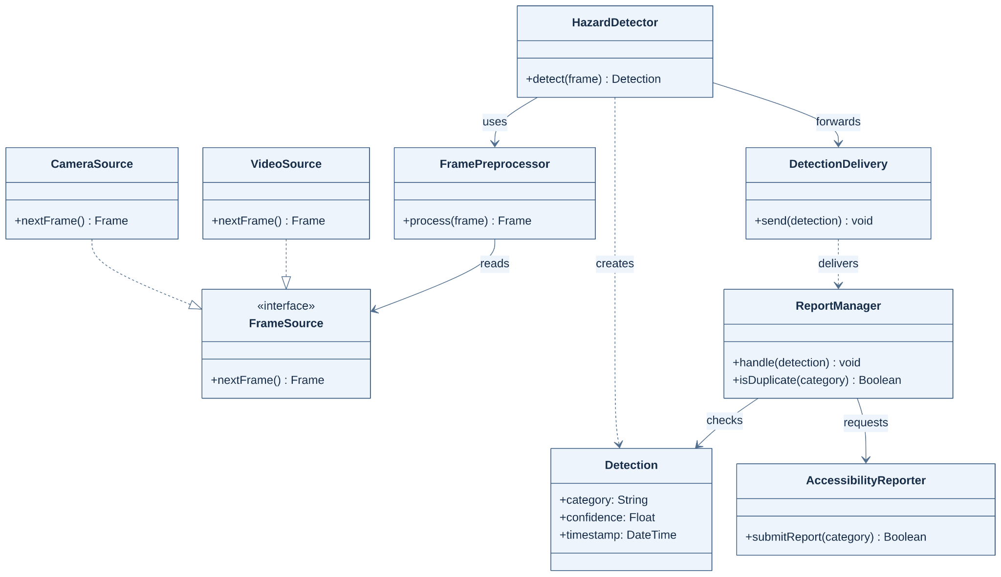
Waze’o’matic: Class Diagram
If the report goes through these checks, the app brings Waze to the foreground and steps through its report menus using the UI elements, tapping the same buttons a user would. This means the driver never has to touch the phone. If Waze fails to submit the report, the app tries a few more times, and if it still does not go through, the user is alerted. Every outcome is logged, which helps with debugging and lets us verify each part of the app and pipeline.

Sprint 1 Requirements Artifacts
Req ID | Criterion ID | Scenario Type | Given | When | Then
1 | 1.1 | Happy Path | A classification has been made on camera vision data for a hazard. | A valid classification category has been sent from inference to phone for action | An accessibility shortcut matching the classification is performed successfully creating the report on Waze.
1 | 1.2 | Error Case | A classification has been made on camera vision data for a hazard. | A valid classification category has been sent from inference to phone for action, but Waze fails to create a report. | Another attempt is made to create a report, and if continuing to fail the user is notified that reports are failing.
1 | 1.3 | Error Case | The phone is connected and the accessibility service is enabled. | A classification is received whose category does not map to any Waze report type | No macro runs, Waze’s state is unchanged, and the unmapped category is logged.
1 | 1.4 | Error Case | The accessibility service permission has been disabled or revoked | A valid classification is received | The app does not attempt the macro. It shows a persistent notification asking the user to re-enable the accessibility service, and logs the skipped report
1 | 1.5 | Edge Case | Waze is running in the background, not the foreground | A valid classification is received | The app brings Waze to the foreground, completes the report as in 1.1, and leaves Waze on the navigation screen
1 | 1.6 | Edge Case | A report for a category was submitted in the last 60 seconds | The same category is classified again within that window | No duplicate report is submitted, and the suppressed event is logged
2 | 2.1 | Happy Path | The camera is connected and the CV pipeline is running. | The camera produces live video frames | Frames are captured, preprocessed to the models input format, and run through inference.
2 | 2.2 | Happy Path | The camera is connected and the CV pipeline is running. | Inference produces a detection with confidence of 0.7 or higher (confidence value subject to change) | A message with the category, confidence score, and timestamp is sent to the phone in a defined JSON format
2 | 2.3 | Edge Case | The pipeline is running and the phone is connected | Inference produces a detection with confidence below .7 | No message is sent to the phone and the low confidence detection is logged
2 | 2.4 | Error Case | The pipeline is running | The camera disconnects or delivers no frames for an extended period of time | The pipeline logs the error and sends a “camera offline” status to the phone without crashing. It retries the camera connection and resumes processing when the camera returns
2 | 2.5 | Happy Path | A pre-recorded test video is set as the input source instead of the camera | The pipeline has started. | Frames from the video are processed exactly like live camera frames.

